**PROBLEMS: BOOLEAN AND CONDITIONAL LOGIC**

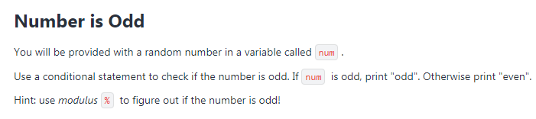

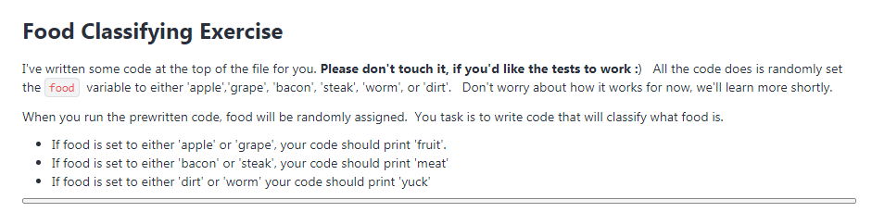

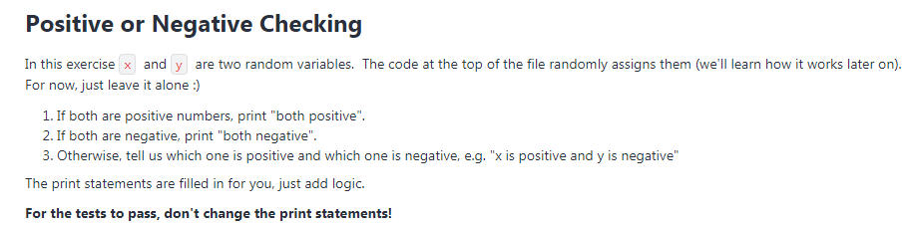

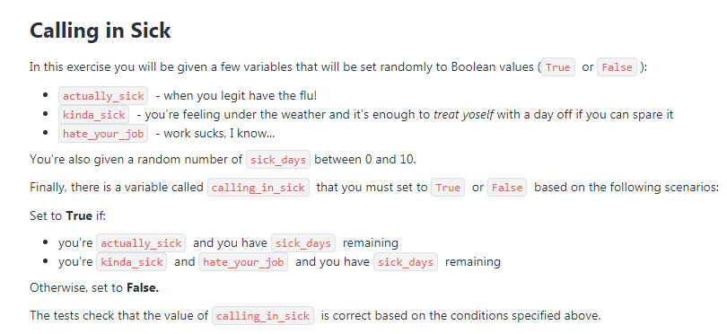

**PROBLEMS: LOOPING IN PYTHON**

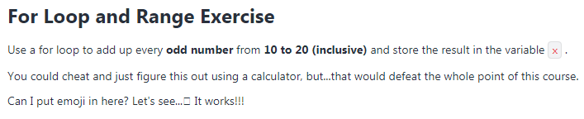

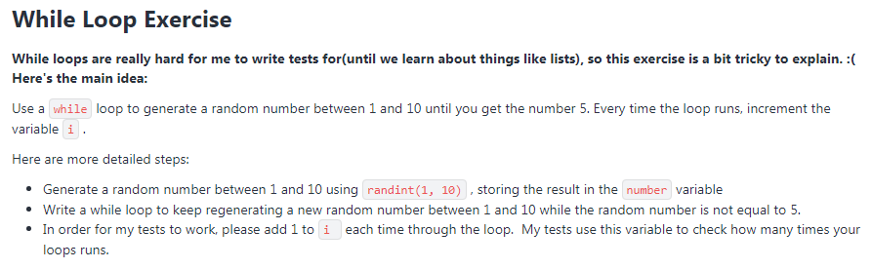

**PROBLEMS: LIST**

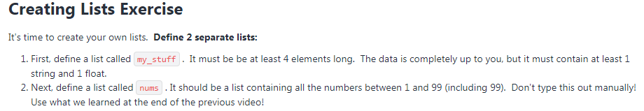

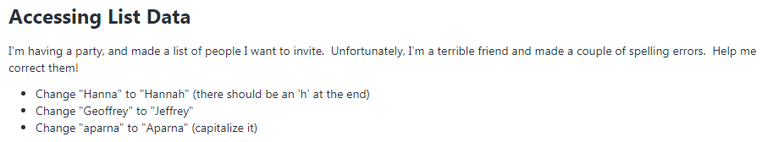

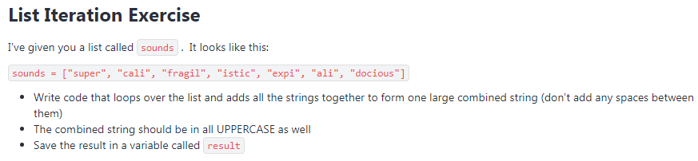

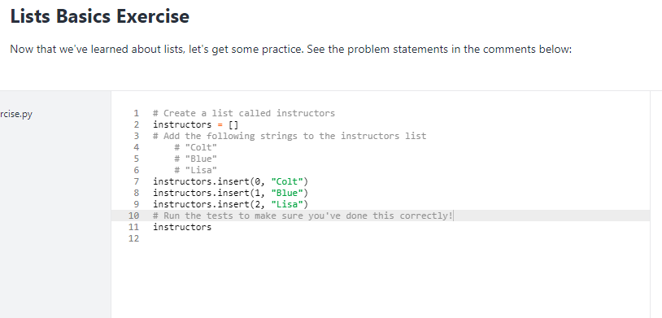

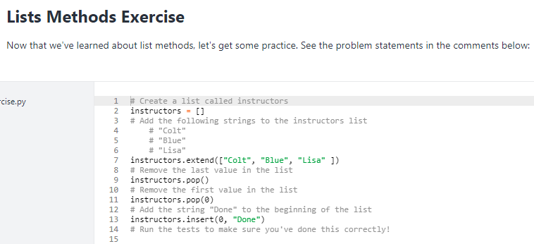

**PROBLEMS: LISTS COMPREHENSIONS**

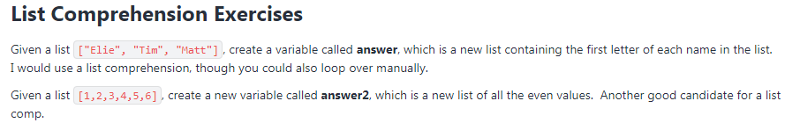

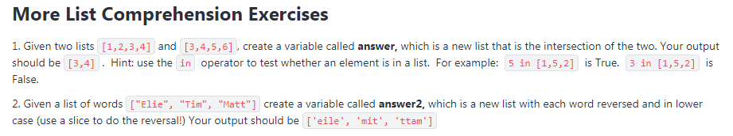

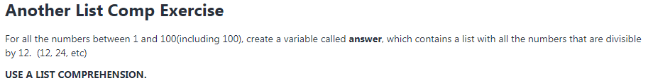

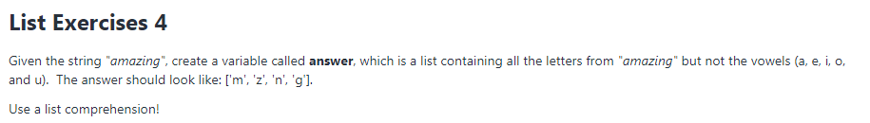

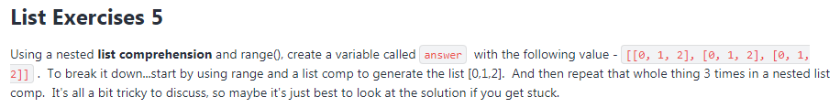

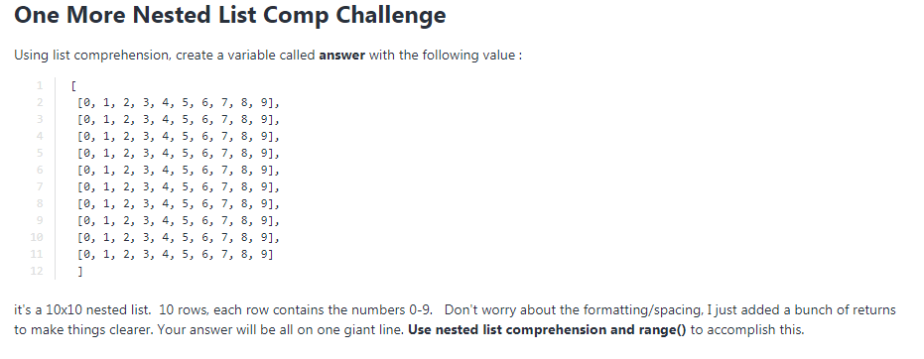

**PROBLEMS: DICTIONARIES**

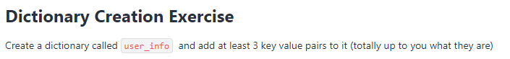

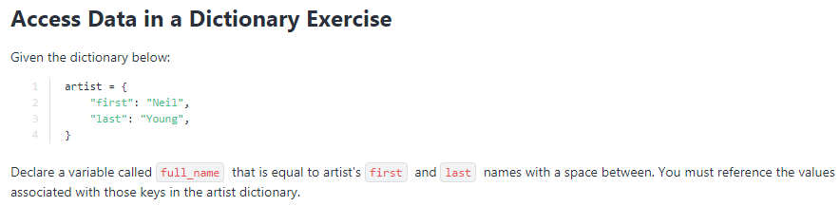

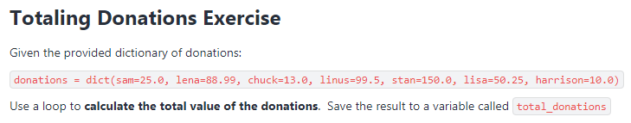

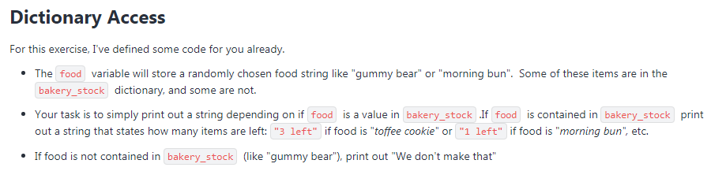

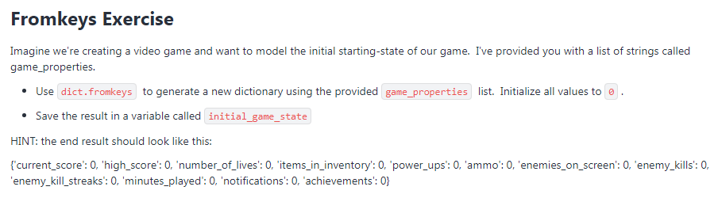

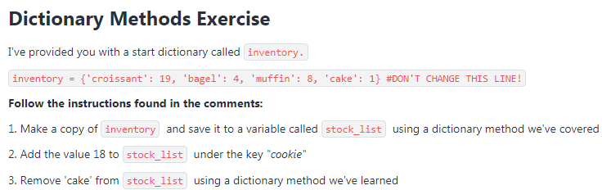

**PROBLEMS: DICTIONARY EXERCISES**

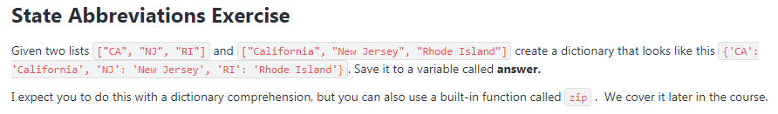

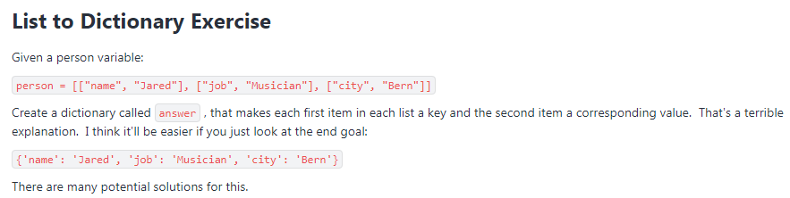

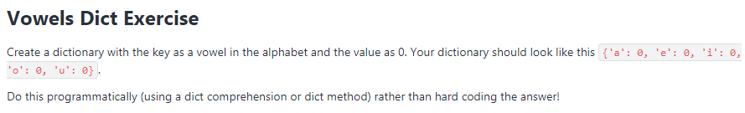

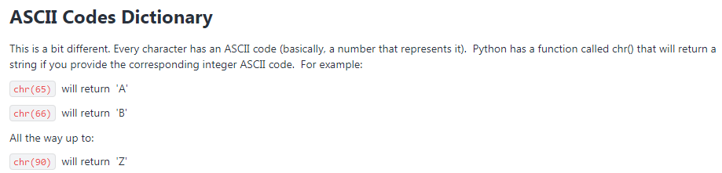

**PROBLEMS: TUPLES AND SETS**

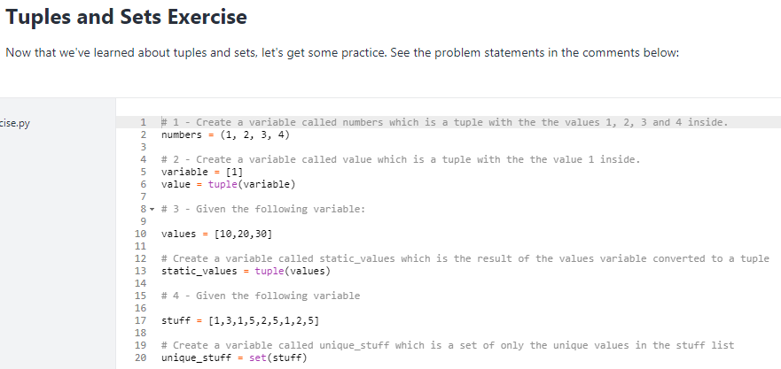

**PROBLEMS: FUNCTIONS PART I**

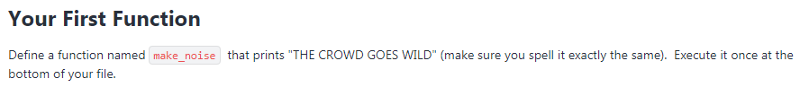

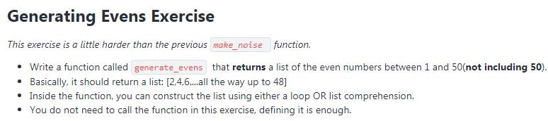

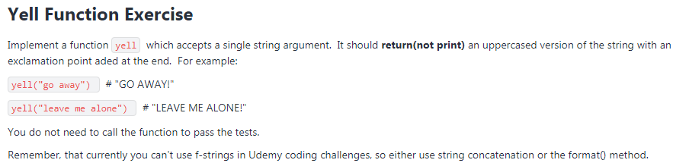

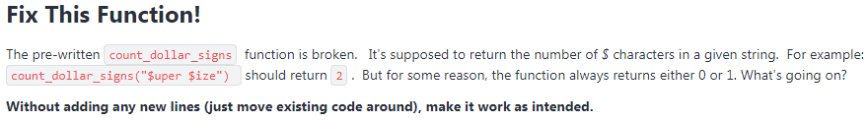

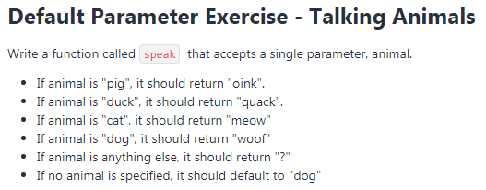

**PROBLEMS: FUNCTIONS EXERCISES**



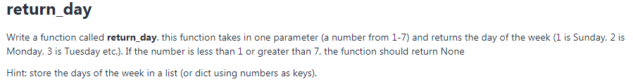

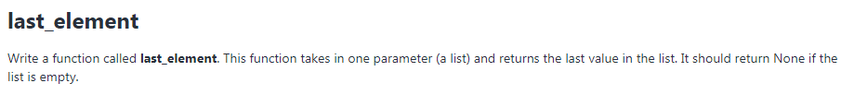

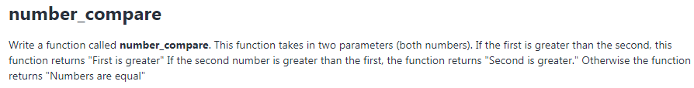

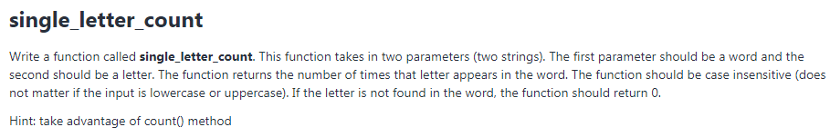

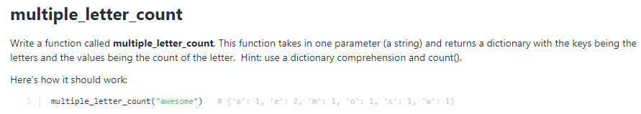

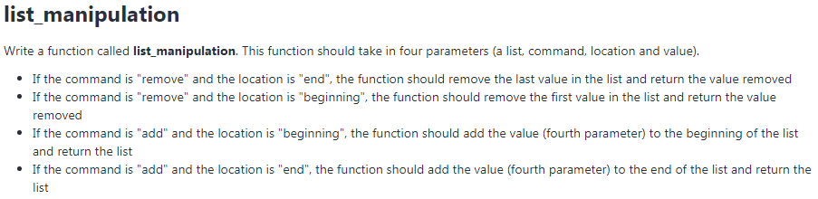

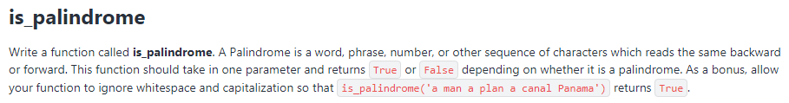

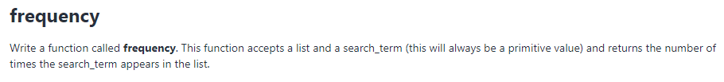



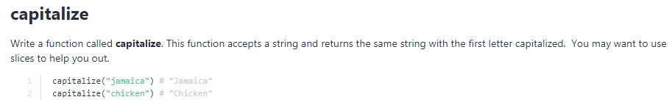

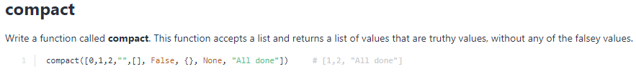

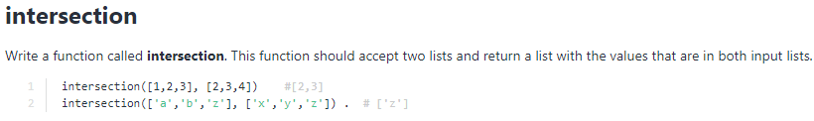

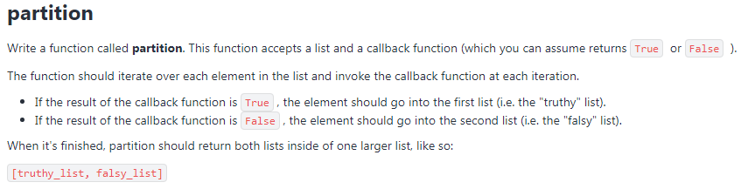

**PROBLEMS: FUNCTIONS PART II**

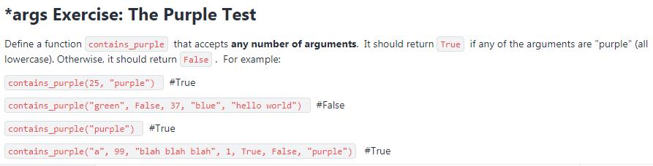

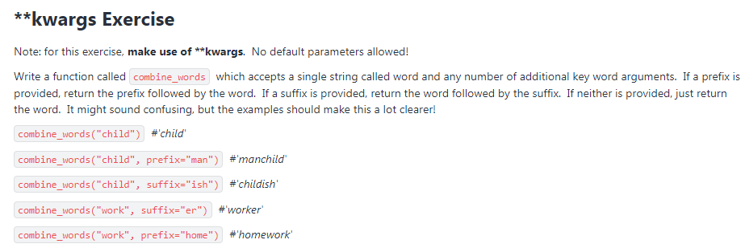

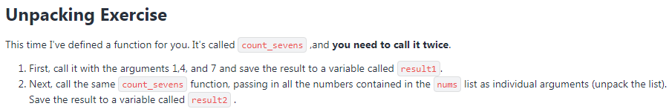

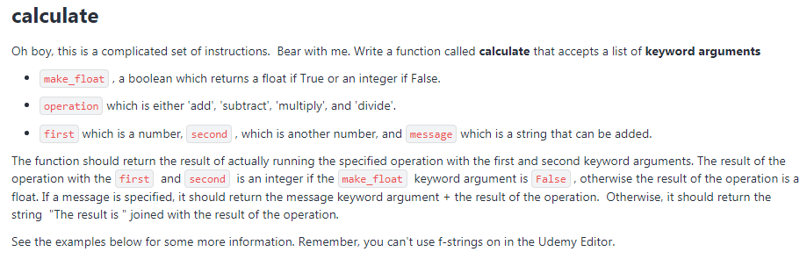

**PROBLEMS: LAMBDAS AND BUILT-IN FUNCTIONS**

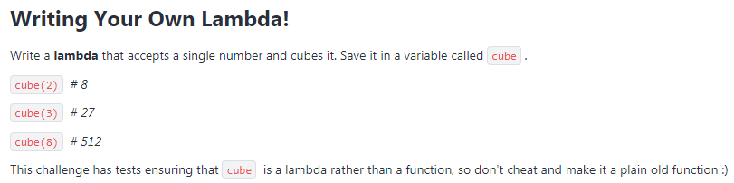

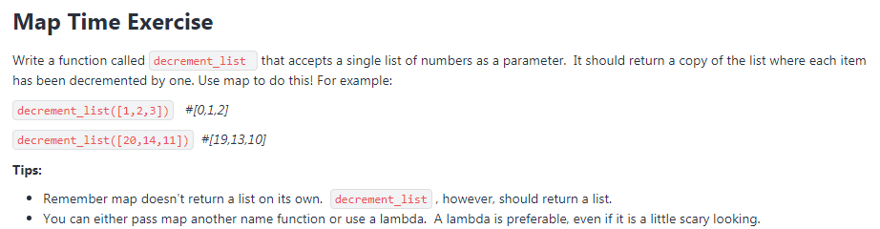

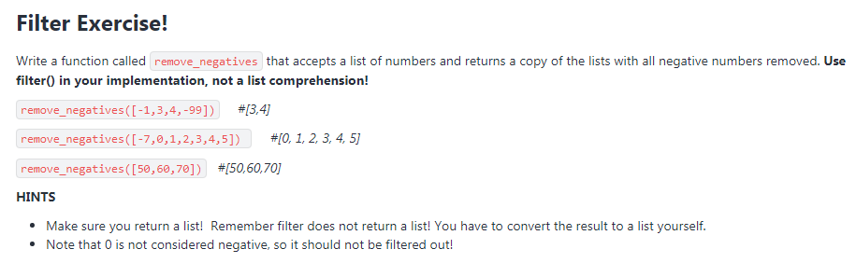

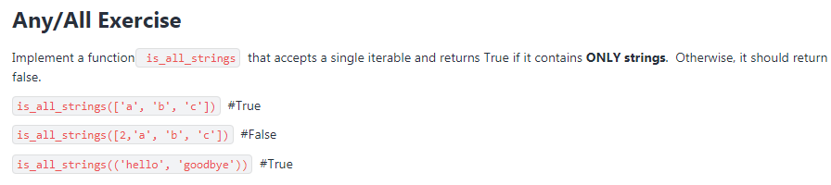

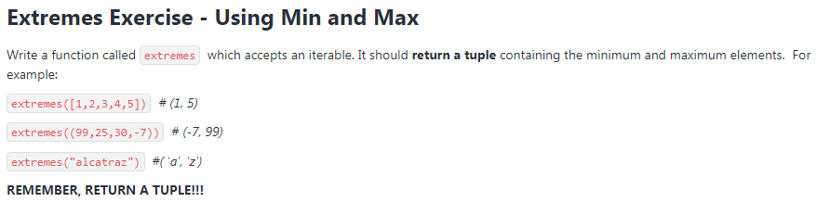

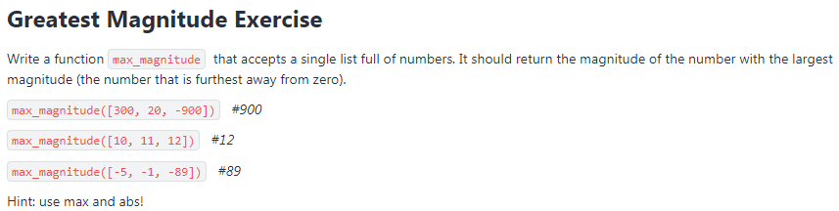

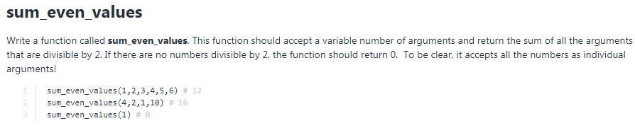

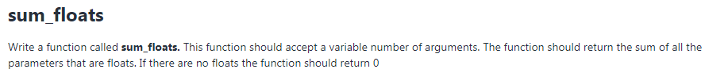

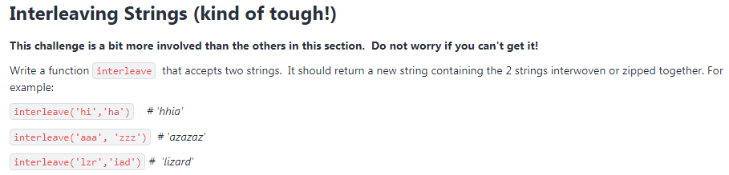

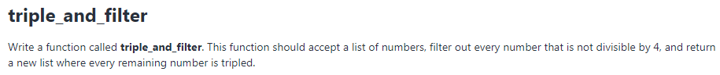

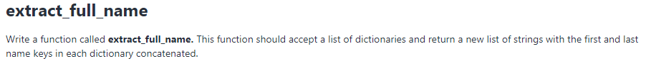

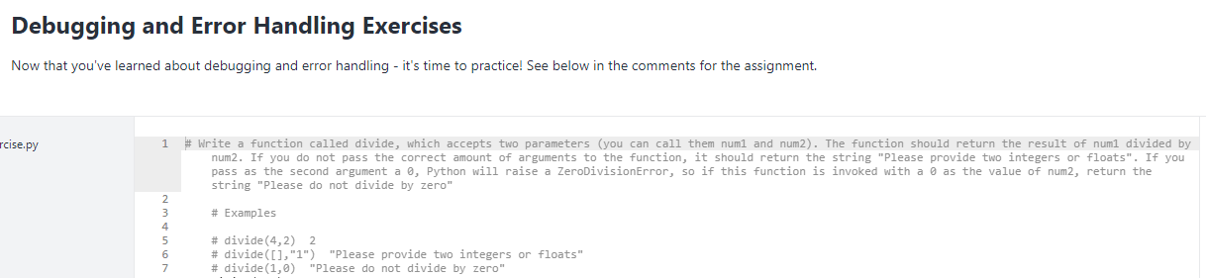

**PROBLEMS: MODULES**

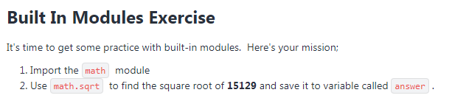

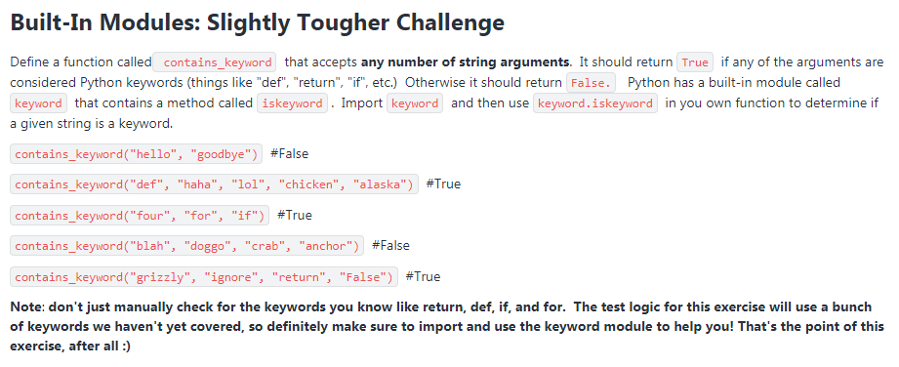

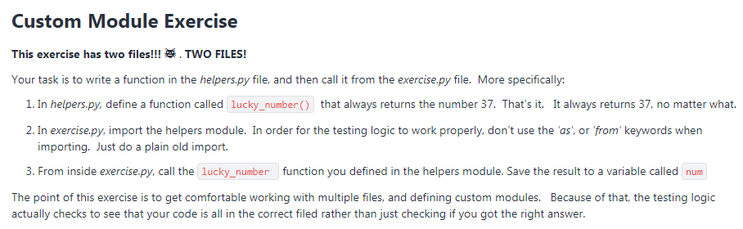

**PROBLEMS: OBJECT ORIENTED PROGRAMMING**

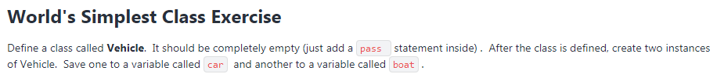

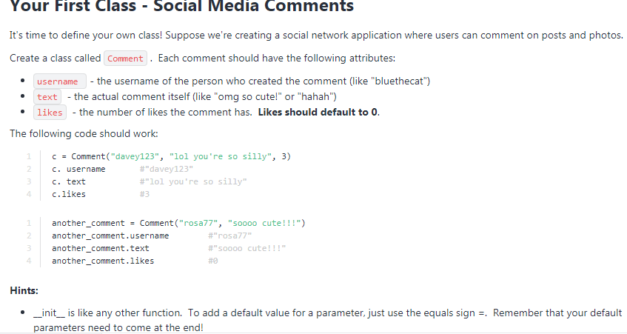

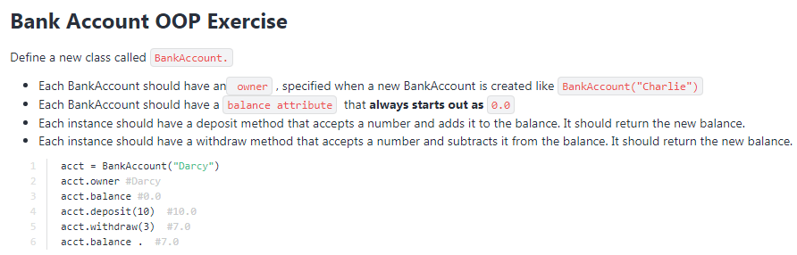

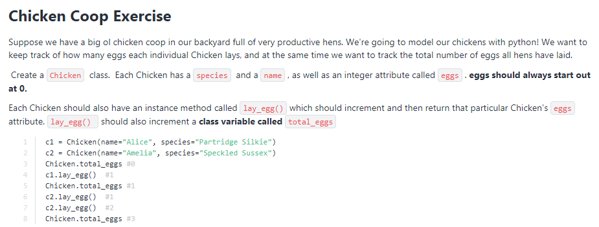

**[Aprender a hacer Deck of Cards sin mirar]**

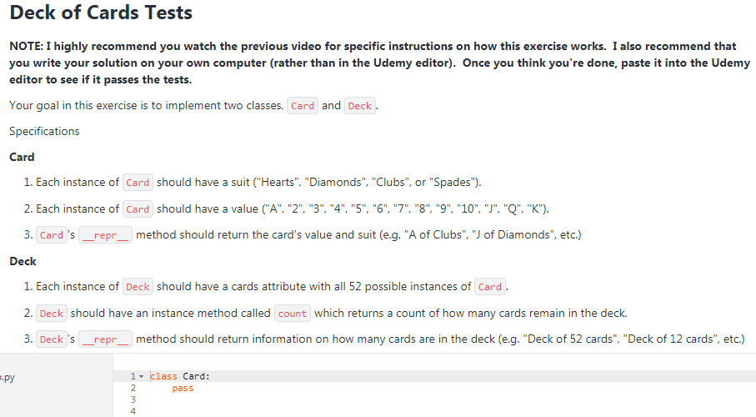

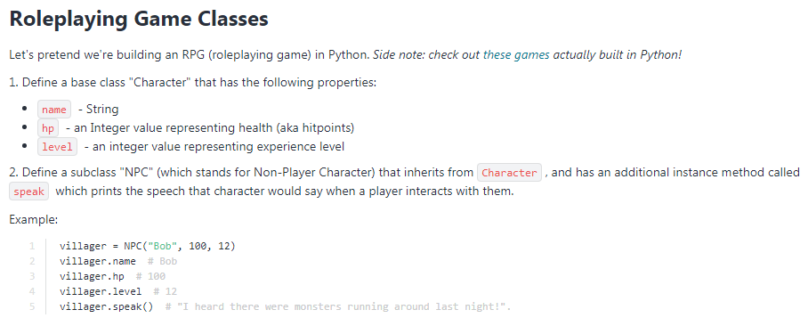

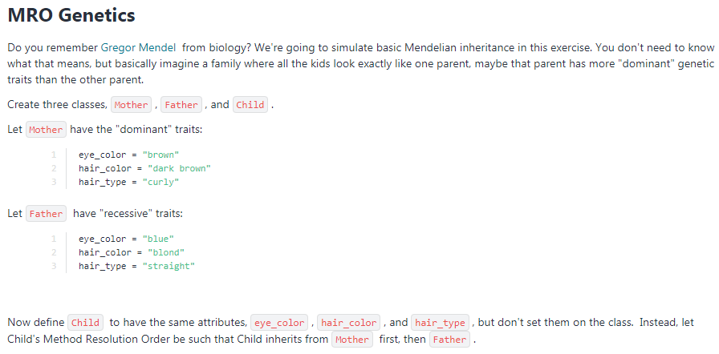

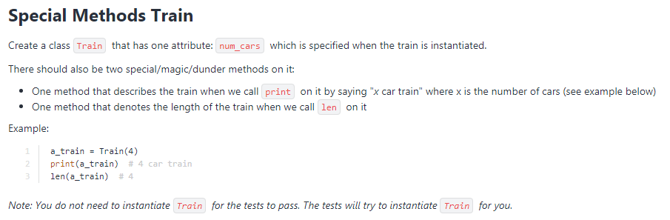

**PROBLEMS: ITERATORS & GENERATORS**

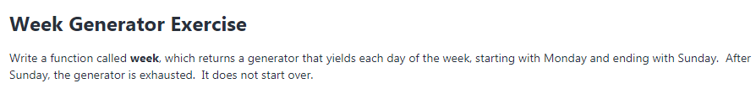

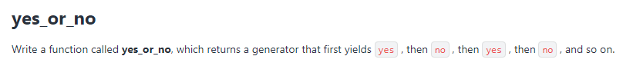

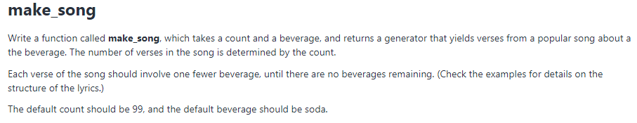

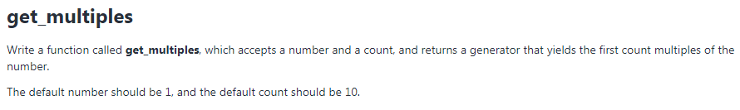

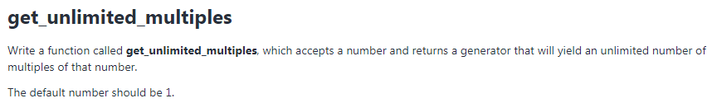

**PROBLEMS: DECORATORS**

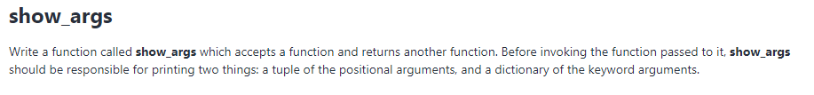

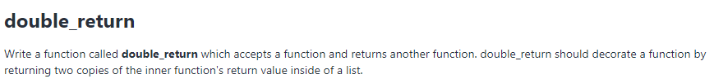

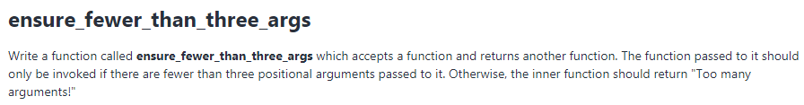

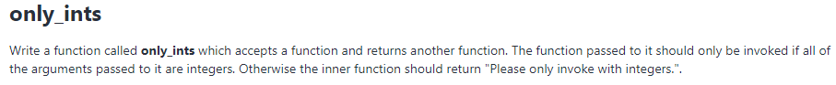

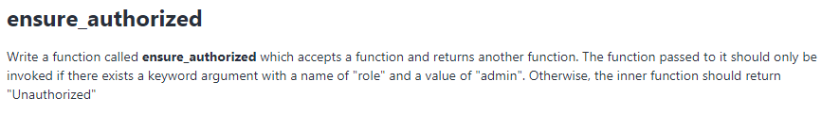

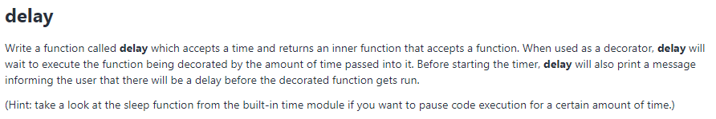

**PROBLEMS: File IO**

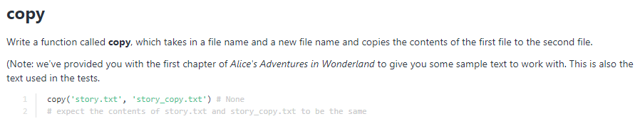

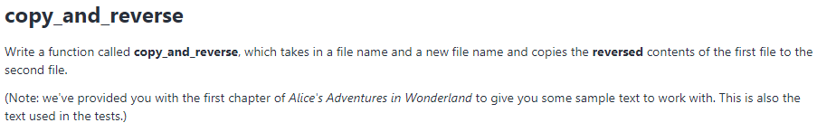

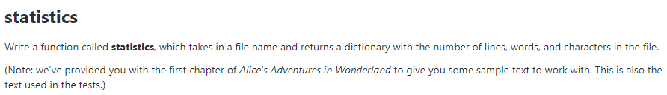

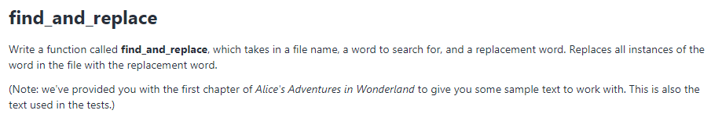

**PROBLEMS: Working With CSV and Pickling!**

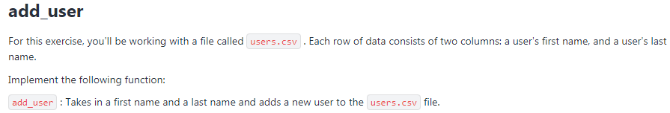

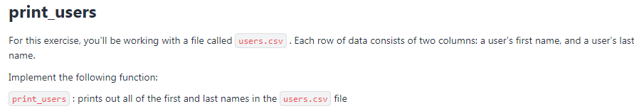

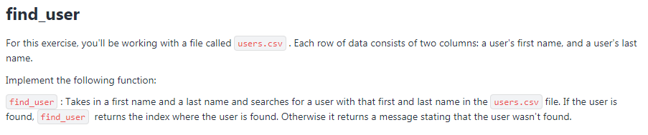

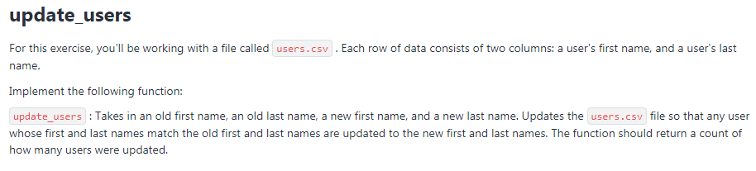

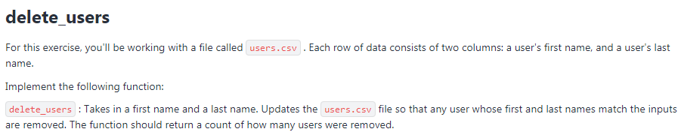

**PROBLEMS: Regular Expressions**

